MGMT640 - Financial Decision Making for Managers

MGMT640: Session 5 – Risk & Return

Learning Objectives
- Explain the relation between risk and return.
- Describe the two components of a total holding period return, and calculate this return for an asset.
- Explain what an expected return is, and calculate the expected return for an asset.
- Explain what the standard deviation of returns is, explain why it is especially useful in finance, and be able to calculate it.
- Explain the concept of diversification.
- Discuss which type of risk matters to investors and why.
- Describe what the Capital Asset Pricing Model (CAPM) tells us and how to use it to evaluate whether the expected return of an asset is sufficient to compensate an investor for the risks associated with that asset.

Expected Rate of Return
The return rate expected to be realized from an investment based on probability of occurrence
If we multiply each possible outcome by the probability of its occurrence and then we add up these values, we end up with a weighted average of outcomes.
The weights = probabilities and the weighted average = Expected Rate of Return
Expected return on an asset, E(RAsset), is a (weighted) average of possible returns on the asset, where the returns are weighed by the probability of their occurrence: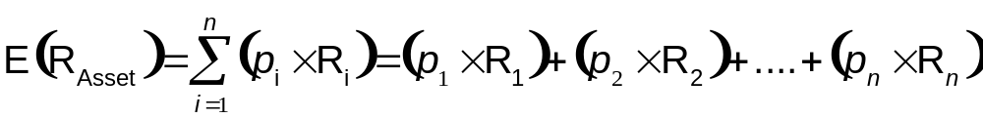

Example:
 | Probability | Return | Prob * Return
Boom | 30.00% | 100.00% | 30.00000%
Normal | 40.00% | 15.00% | 6.00000%
Recession | 30.00% | -70.00% | -21.00000%
 |  |  | 15.00%

The expected return is 15%.

Holding Period Return
Risk & return: the greater the risk, the larger the return that investors expect on the asset as compensation for bearing the risk, i.e., investors are risk averse.
Quantitative measures of return
Total holding period return = capital appreciation of an asset over a period plus its income over the period as a percentage of the asset’s price at the beginning of the period, i.e.,

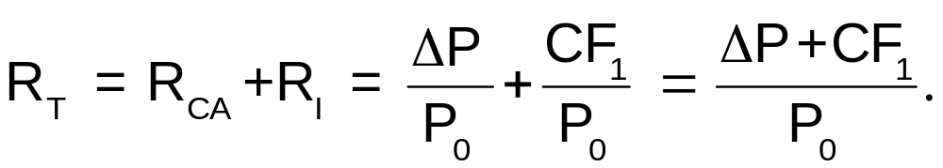
The return over the period in which an investment is held
HPR = (End Price – Beginning Price)/Beginning Price
If dividends are paid, you have to include them.
HPR = (End Price – Beginning Price + Dividends)/Beginning Price
To annualize the returns, you need to find the annual return. This is simply the HPR that you calculated divided by the number of years .

Effective Annual Rate (Stock)
Can apply EAR to Stock.
The annual rate of interest actually bearing earned/charged as opposed to the stated rate
Formula: ((PIR +1)^Compounding Frequency) -1
PIR = (End Price + Dividends – Initial Price)/Initial Price

Variance
Most investors are risk adverse. They want to minimize the amount of risk they must accept in order to achieve a specific level of return.
Variance tells the investor the range of possible outcomes.
Quantitative measures of risk:
The variance ($σ^{2}$) and its squared root (i.e., σ or the standard deviation) are the two basic measures of risk in finance. $σ^{2}$or σ of returns on an asset show how spread out are the returns on asset.
The variance $σ^{2}$: squares the difference between each possible return and the mean (expected) return, then multiplies each ‘squared difference’ by its associated probability before summing them up; i.e.,
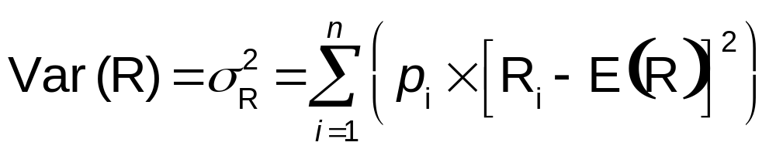

Standard Deviation
- Stock Risk is measured by the standard deviation
- The higher the SD, the higher the risk
- Measures how far from the expected return value the actual return might be
- Two stocks may have the same level of return but differing amounts of risk
- Standard Deviation allows the investor to see which portfolio creates an overall level of risk that is acceptable
That σ and/or $σ^{2}$ are good measures of risk is best illustrated if one assumes that returns have a normal distribution.
Standard deviation example:
Stock A: Exp. Return = 5%
Outcome | Probability | Return | Exp. Return
Good | .5 | 7% | 3.5%
Bad | .5 | 3% | 1.5%
 |  |  | 5%

Stock A: Exp. Return = 5%
Outcome | Probability | Return | Exp. Return
Good | .5 | 15% | 7.5%
Bad | .5 | -5% | -2.5%
 |  |  | 5%
Both Stock A and Stock B have the same Expected Return—5%. However, in the Stock A Bad scenario, an investor sill earns 3%. In the Stock B Bad scenario, an investor loses 5%.
This illustrates risk tolerance: a 3% return might be acceptable but a 5% loss might be unacceptable.

Calculate Standard Deviation
- Calculate the mean of the stocks (simple average)
- For each number, subtract the mean.
- Square the result
- Add up all of the squared results
- Take the Square Root of the sum
Stock Risk is measured by the standard deviation.
The higher the SD, the higher the risk.
Example of the SD calculation can be found here:
http://teachmefinance.com/standarddeviation.html
In the grid box, the answer is shown as 66.25. This is the variance---not the Standard Deviation.
To find the SD, you need to take the square root of the variance.
In Excel, the square root function is SQRT()

Risk and Diversification
When thinking about Risk and Diversification, the idea is to create a portfolio of stocks that work well together. This usually means that a portfolio should hold stocks that move in opposite directions. If it only holds stocks that move in the same directions, the portfolio will do very well in up times and very poorly in down times.

Portfolio Risk and Return
- Most investors do not hold only one stock or bond (securities). They have many securities. Combined this is called the investor portfolio.
- What an individual security does (up/down) is not important. What IS important is how the portfolio as a whole performs.
- The risk and return of an individual security should be analyzed in terms of how it impacts the portfolio in which it is held.

Risk and Diversification
Risk & Diversification: reducing risk by investing in two or more assets whose values do not always change in the same direction and/or by the same rate.
Single-asset portfolios:
- a selection criteria could be low coefficient of variation of return, i.e., low risk per percentage rate of return.
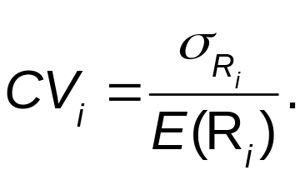

- Existence of risk-free assets with positive returns presents interpretation problems for CV. Hence, modified CV and its inverse (i.e., Sharpe ratio)

Portfolio Risk
Portfolios with more than one asset: Expected return on a portfolio of two assets is the weighted average of the expected returns on the two assets, i.e.,
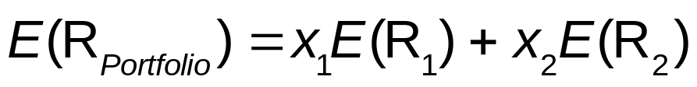
Similarly, expected return on a portfolio made up of n assets is given by:
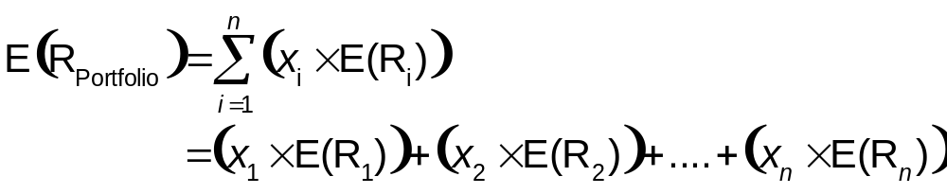
Risk (e.g., variance of returns) on a portfolio made up of two or more assets IS NOT equal to the weighted average of risks of individual assets. Variance of returns for two assets is:
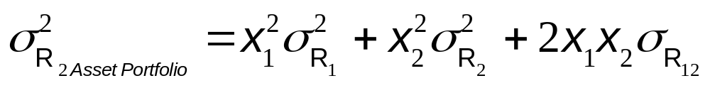
where R1,2 is the covariance between stocks 1 and 2. Covariance is a measure of how returns on two assets co-vary, or move together:
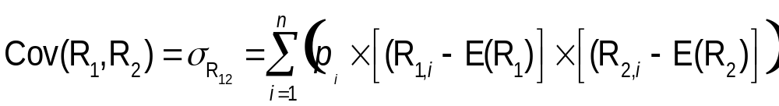
Note that covariance calculation is similar to variance calculation; but instead of squaring difference between value from each outcome and expected value for an individual asset, we calculate the product of this difference for two different assets. If we divide covariance by the products of standard deviations, we get the correlation coefficient between returns on two assets, i.e.,
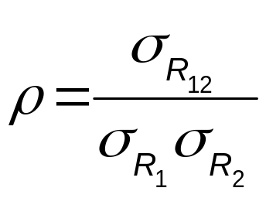
Coefficient of correlation always is between +1 and -1.
If we have an imperfect correlation between assets, or a correlation coefficient less than +1, then we benefit from diversification by holding more than one asset with different risk characteristics.
As we keep adding stocks to a portfolio, calculating variance becomes increasingly complex – we must account for covariance between each pair of assets.
By increasing number of stocks in a portfolio, the portfolio risk – or the standard deviation of portfolio returns declines, but at diminished rates.

Covariance
Covariance measures how 2 variables move together. If they move in the same direction, there is a positive covariance. If they move in opposite directions, there is a negative covariance.
Following is the formula for calculating the covariance—but what does this math really mean?
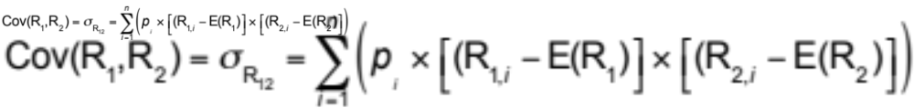
This equation says for each stock, take the probability and multiply it by the (stock returns – expected return for that stock).
Example:
Calculate the covariance between the returns of Stock A and Stock B given the following:
 | Probability | Return A | Return B
Good | .35 | .3 | .5
Fair | .5 | .1 | .1
Poor | .15 | -.25 | -.3
Expected returns |  | .1175 | .18

Solution:
 | Probability  Based on past data | Return A | Return B | Return A – Expected Return A | Return B – Expected Return B | Future  Probability
Good | .35 | .3 | .5 | .1825 | .32 | .02044
Fair | .5 | .1 | .1 | -.0175 | -.08 | .00070
Poor | .15 | -.25 | -.3 | -.3675 | -.48 | .02646
Expected returns |  | .1175 | .18 |  |  | .0476 or  4.76%
[Future Probability = (Probability based on past data) * (Return A – Expected Return A)*( Return B – Expected Return B)]
=sum (.02044 + .00070 + .02646) = 4.7600%

Portfolio and Systematic Risk
Portfolio with more than one asset- Investors can diversify away risk unique to individual assets, but cannot diversify away risk common to all assets, i.e., they can not eliminate systematic or market risk. With complete diversification, all unique ( or unsystematic) risk is eliminated from portfolio; investor still faces systematic risk.
Systematic risk is all that matters. Why?
Diversified investors face only systematic risk; others face systematic risk plus some unsystematic risk. Hence, Diversified investors will be more willing to pay higher prices for individual assets than other investors.
Expected returns on individual assets will be lower than total risk of those assets suggests they should be. Only systematic risk is rewarded in asset markets.
Measuring systematic risk
Systematic risk cannot be measured by standard deviation. σ measures total risk. Since systematic risk is, by definition, risk that cannot be diversified away, systematic risk (or market risk) of an individual asset is really just a measure of relationship between returns on individual asset and returns on market. It can be found by regressing returns on the asset on the returns on the market (e.g., S&P 500).
- Beta (β ): The slope of the line of best fit.
Compensation for bearing systematic risk:
Government securities are risk free. Their holders are not compensated for bearing any systematic risk. Hence, expected return on ith asset is
E(Ri) = Rrf + Compensation for taking Risk i.
Or, E(Ri) = Rrf + (Units of Risk i compensation per unit of risk).
Or, E(Ri) = Rrf + (βi compensation per unit of risk).
We know that compensation per unit of systematic risk = E(Rm) – Rrf. Hence, E(Ri) = Rrf + βi(E(Rm) – Rrf).

Capital Asset Pricing Model
Framework for analyzing the relationship between risk and rates of return.
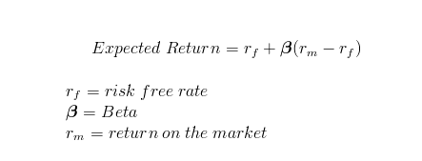
Risk Free Rate - The rate expected on an investment that has zero risk. The US T-bill rate is frequently used as the measure for the risk free rate.
Beta Coefficient - Measure of a stock’s movement relative to an average stock. An average risk stock is one that tends to move up and down with the market as measured by an index such as the Dow or the S&P 500.
Some benchmark betas:
b = .05: Stock is ½ as volatile (risky) as the avg. stock
b = 1.0: Stock is avg risk
b= 2.0: Stock is twice as volatile
Beta Portfolio – Measure of the portfolios volatility.
The beta of a portfolio is determined by the weighted average sum of each of the individual stocks
Weighted average = Percent of Portfolio * Beta
Portfolio Weight = Market Value/Total Market Value

Security Market Line
Visual representation of CAPM
